# Specificity of human capital: evidence based on the job-to-job transitions

Eduardo Levy Yeyati

Martín Montané

## Introduction[1]

The analysis of movements between employers, industries, occupations and workers' tasks has been a topic extensively studied in recent decades. Two factors have contributed strongly to this phenomenon: 1) the increasing penetration into the technology labor markets that can potentially replace labor in various production processes and 2) the emergence of new databases of higher quality and relevance to these investigations.

Advances on this topic have been mainly applied where administrative data is most accessible or long-standing panel type surveys are conducted. This is how papers that analyze the mobility of workers across industries, occupations and tasks are available for countries such as the United States, Germany, Sweden or Denmark.

In the Argentine case two research works have gone in this direction. Montané and Sartorio (2019) used the data in the Permanent Household Survey (EPH), a quarterly frequency survey with representativeness of 62% of the Argentine population, to study the movements of workers between occupations according to the National Occupational Code (CNO), and also information on the movement of registered wage workers between activities according to the Longitudinal Sample of Registered Employment prepared by the Ministry of Labor and Social Security (ML&SS). On the other hand, De Raco and Semeshenko (2019) studied similarities and differences between Argentina and Germany’s networks from the analysis of movements between industries using administrative data.

This work aims to characterize the graph that arises from the movements between occupations of workers of the Permanent Household Survey (EPH) and use that distance measurement to assess whether occupations that are less similar to each other bring associated major falls in wages.

## The distance measure between occupations

The methodology used in this work is based on the theoretical contributions of the literature of economic complexity and its derivatives (for example Hidalgo et al (2007), Hidalgo and Hausmann (2009), Neffke and Henning (2013), and Neffke et al (2017)). The objective of all this literature is to identify similarities between different variables (productive capacities of countries, demand for similar skills between industries, among others) through the observed flows of variables we could call "of results".

This methodology requires the definition of a "base case" of flow between the units (countries, industries, workers), i.e. the flow that is expected to exist if there is no specific attraction between the units. Once this expected flow is identified, this value is compared against the observed flow and conclusions are drawn about the differences.

This way of detecting non-random patterns has analogies in other domains, for example, in spatial statistics to compare crime rates in different regions relative to the average, which would indicate a random distribution in spatial terms. It is also similar to the methodology in contingency table tests as de Raco and Semeshenko (2019) point out.

However, the strategy used to determine the selection of this base scenario has varied throughout literature. For example, Hidalgo et al (2007) create this base scenario using Balassa's concept of Revealed Comparative Advantage (RCA) (1986). Analyzing international trade between countries we define the RCA of country c in product p by the following formula:

$RCA_{cp} =(VE_{cp}/\sum_{p=1}^{P}{VE_{cp}}$) / ($\sum_{c=1}^{C}{VE_{cp}}/\sum_{c=1}^{C}{\sum_{p=1}^{P}{VE_{cp}}})$

where $VE_{cp}$ is the exported value of the product p by country c. Thus, a value less than one in this indicator implies that the country exports a lower proportion of that good relative to the global average, and a value greater than one implies the opposite. Therefore, the expected flow is the value that would have been observed if the export of that product was distributed evenly in each of the countries.

This notion can easily be adapted to the movement of workers between occupations simply by observing the flows of workers (renamed in F) coming out of occupation i to j. Following Neffke et al (2017), we will establish the expected flow of workers’ movement between occupations taking into account the outflows and inflows of the occupations between which the workers moved. If the relative output and input size could be used to explain the flow of workers, then the expected flow between sector i and j would be given by $\hat{F_{i,j}}=\frac{F_{i,*}*F_{*,j}}{F_{*,*}}$. In this way, we can measure the "likeness" between occupations by the ratio between expected and observed flows, which after a small algebraic arrangement has the following form:

$$R_{i,j}=\frac{F_{ij}*F_{**}}{F_{i,*}*F_{*,j}}$$

where asterisks (*) refer to all sectors. In this way, the similarity between occupation i and occupation j ($R_{ij}$) is given by a variable that goes between zero and infinite. A value smaller than 1 implies a movement of workers below the expectations, while one greater than 1 implies the opposite. However, this distance measurement has an asymmetric distribution, with extreme values toward the values on the positive side. To be able to count with a measure symmetrically distributed around a value (0) we do the following transformation:

$$\overline{R_{i,j}}= \frac{{(R}_{ij}-1) }{(R_{ij}+ 1)}$$

This measure of distance is symmetrical and bounded between -1 and 1

## The facts: the Permanent Household Survey

This work uses data from the Permanent Household Survey (EPH), the household survey in Argentina. It systematically reveals information on the socio-economic situation of most of Argentina's urban population, reaching approximately 64% of the country's population.

The survey is carried out continuously and on a quarterly basis since the second quarter of 2003, with some quarters missing in 2007, 2015 and 2016. Like many other household surveys in other countries, the sample design has a rotative nature. In this scheme, the same home is relieved for four noncontiguous quarters. A household is surveyed twice in a row, then for two quarters it is not surveyed, and finally enters the sample for two more quarters. In this way, the dynamics of a home can be observed for a maximum period of approximately 18 months. This work exploits these short temporary windows to know between which occupations workers often move and to establish similarities based on these flows.

Occupations are included in the National Occupational Code (CNO/2001). It is a hierarchical occupation classifier, in which the first two digits correspond to occupations with a high level of aggregation, while the rest of the digits refer to the level of qualification, technology, and hierarchy.

The interest of this work lies in the movements between occupations, and not between the qualification, technology or hierarchy, so only the first two digits of the CNO, which refer to the group of occupations, will be taken into account. In total, these are 52 large groups of occupations (see Table 1 of the Annex). In addition to this data, we have information on income from the main occupation, which will be used to analyze the relationship between change of occupation and change in wages.

Although these are short trajectories, this exercise is similar to the one performed by Nedelkoska et al (2018). In this paper, researchers used monthly data from the U.S. Current Population Survey (CPS), with a 15-month time window, virtually identical to the one of the EPH.

A relevant factor in measuring the distances between occupations is to take into account the regional factor of labor markets. At least part of the flows is likely to be explained by the simple fact that some occupations are more in demand in some areas, and aggregated flows at the national level hide this effect. For this reason, this document works only with data from the City of Buenos Aires and Greater Buenos Aires, which for practical purposes can be considered as a consolidated labor market.

This leaves us with 212,455 observations from people who at least once reported working while they were in the survey. The next step is to determine when a person changed jobs. This is not just a challenge in this exercise, but other articles have also encountered difficulty at this point (see Kambourov and Manovskii, 2009).

In the specific case of the EPH, there is a question in which seniority in the occupation declared as principal is revealed. Using this question, this work recognizes a change of employment, and therefore assesses whether there were any occupational changes, provided that the difference between the surveyed quarters is greater than the time of experience declared in the main occupation. In addition, it will be considered an employment transition if the person has reported being unemployed or inactive between two observations in which he was occupied, beyond seniority in employment. Given all these conditions, 9,299 job changes were identified between 2003 and 2019, the sample used is on the next pages.

## Descriptive analysis of worker movements

Before displaying the analysis of the resulting graph and estimating the regression and machine learning models, this section proposes a characterization of the detected transitions and an analysis of robustness of the switch detection. Of the 9,299 work transitions, 3,717 correspond to movements that included a period of unemployment or intermediate inactivity, while the remaining 5,582 were detected through the seniority declared with the employer.

The importance of differentiating these labor movements is that a different cost is expected of a job reinsertion of a person who sought a job, but did not find it for a while, than someone else who got a job quickly. On the one hand, people who are inactive/unoccupied during the transition may be more demanding, so when they get a job it will be of a better condition than those who achieved it without reporting this intermediate state. On the other hand, it is also likely that those who go through unemployment or rigor inactivity will have greater problems getting jobs, and that the insertion they achieve is worse than they had in the first place.

Figure 1 shows us, in fact, that we are talking about different job insertions between the groups under analysis. The biggest difference is between them who have gone through a period of unemployment or inactivity compared to the rest of the workers who did not: the average salary[2] of the first group is systematically lower than that of the other two, except for a short period between 2014 and 2015. However, this does not relate to *changes* in wages, but to *levels.* The relevance of the different transition types is evaluated on the following pages.

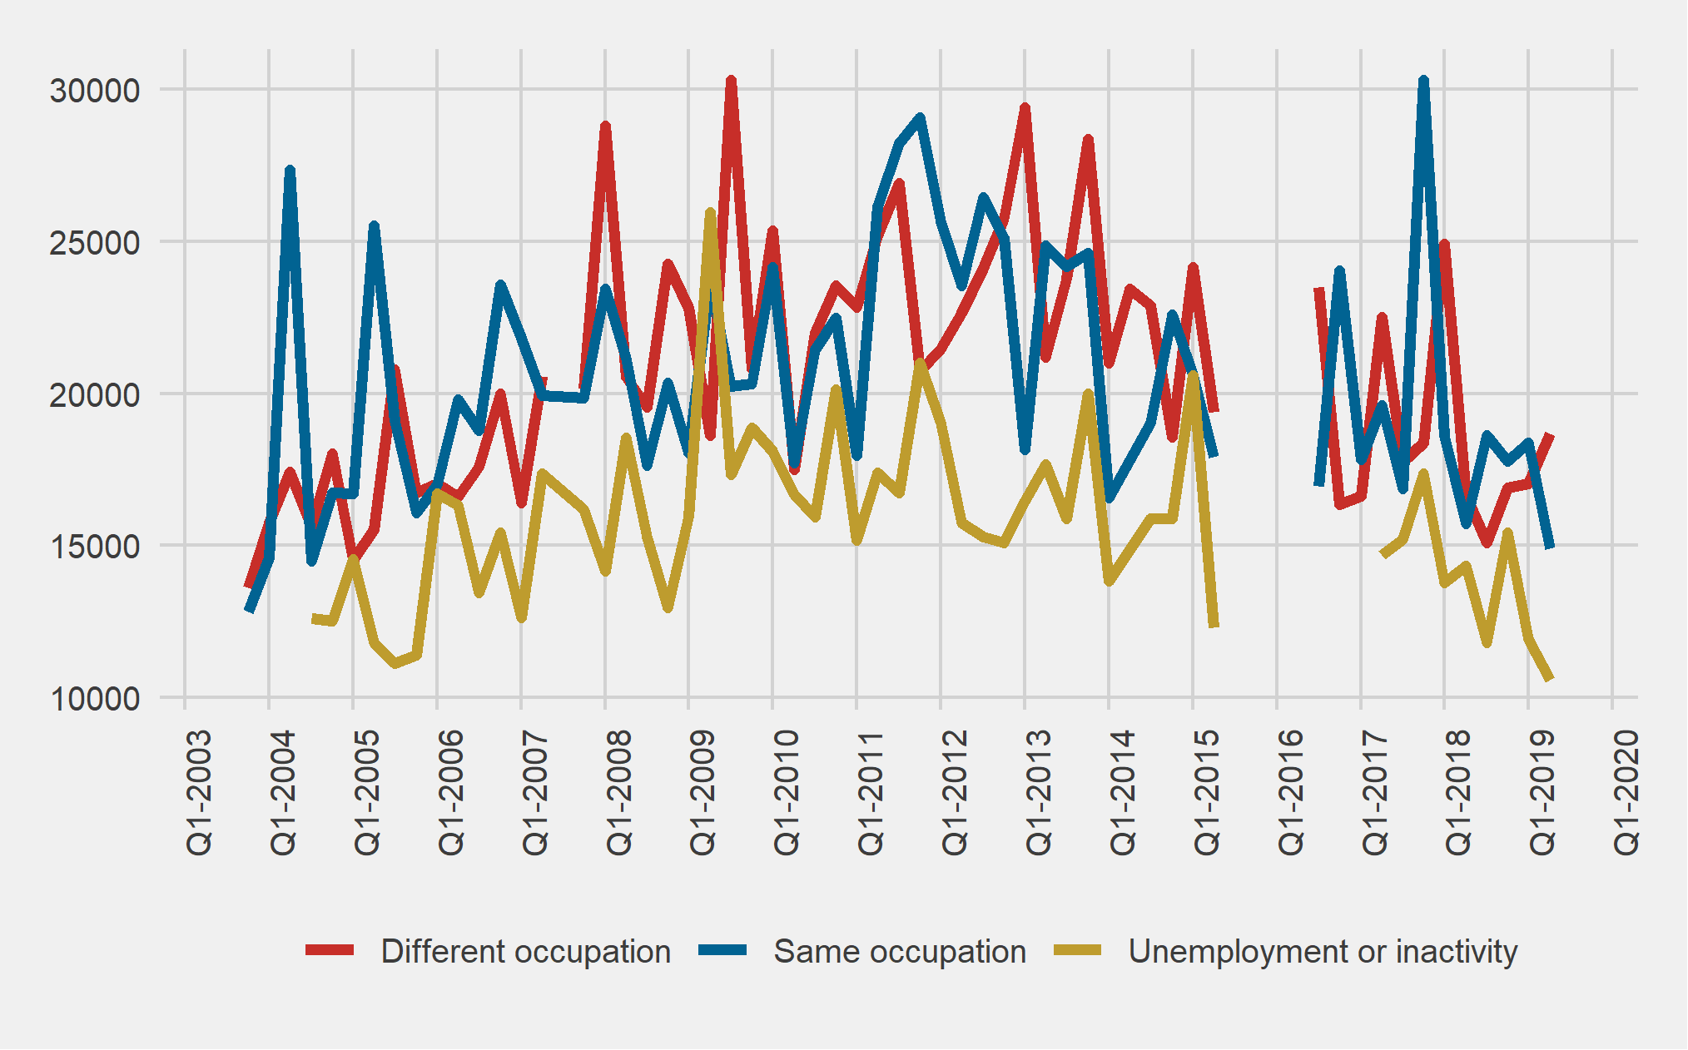

**Figure 1**. Evolution of the real wage of the main occupation according to the type of transition. Different occupation: they changed jobs from one occupation to a different occupation; same occupation: they shifted employment towards the same occupation; inactivity: they changed jobs and went through a period of unemployment or inactivity. Own elaboration based on the Permanent Household Survey (EPH) and Consumer Price Indexes (CPIs) of provincial statistics and census addresses and INDEC.

The National Occupational Code (CNO) is one of the most important restrictions for the analysis of this work. The Annex describes the occupations we are working with and one can easily find out that these are occupations with a high degree of aggregation. This causes that only a handful of occupations explain more than 50% of the transitions between occupancy sectors (Figure 2). In fact, only two occupations (Construction and Commerce) account for almost 33% of departure and arrival occupations. This fact is resumed in the subsequent analysis, since the estimated distance measurement over sectors with so little count can introduce error to the analysis.

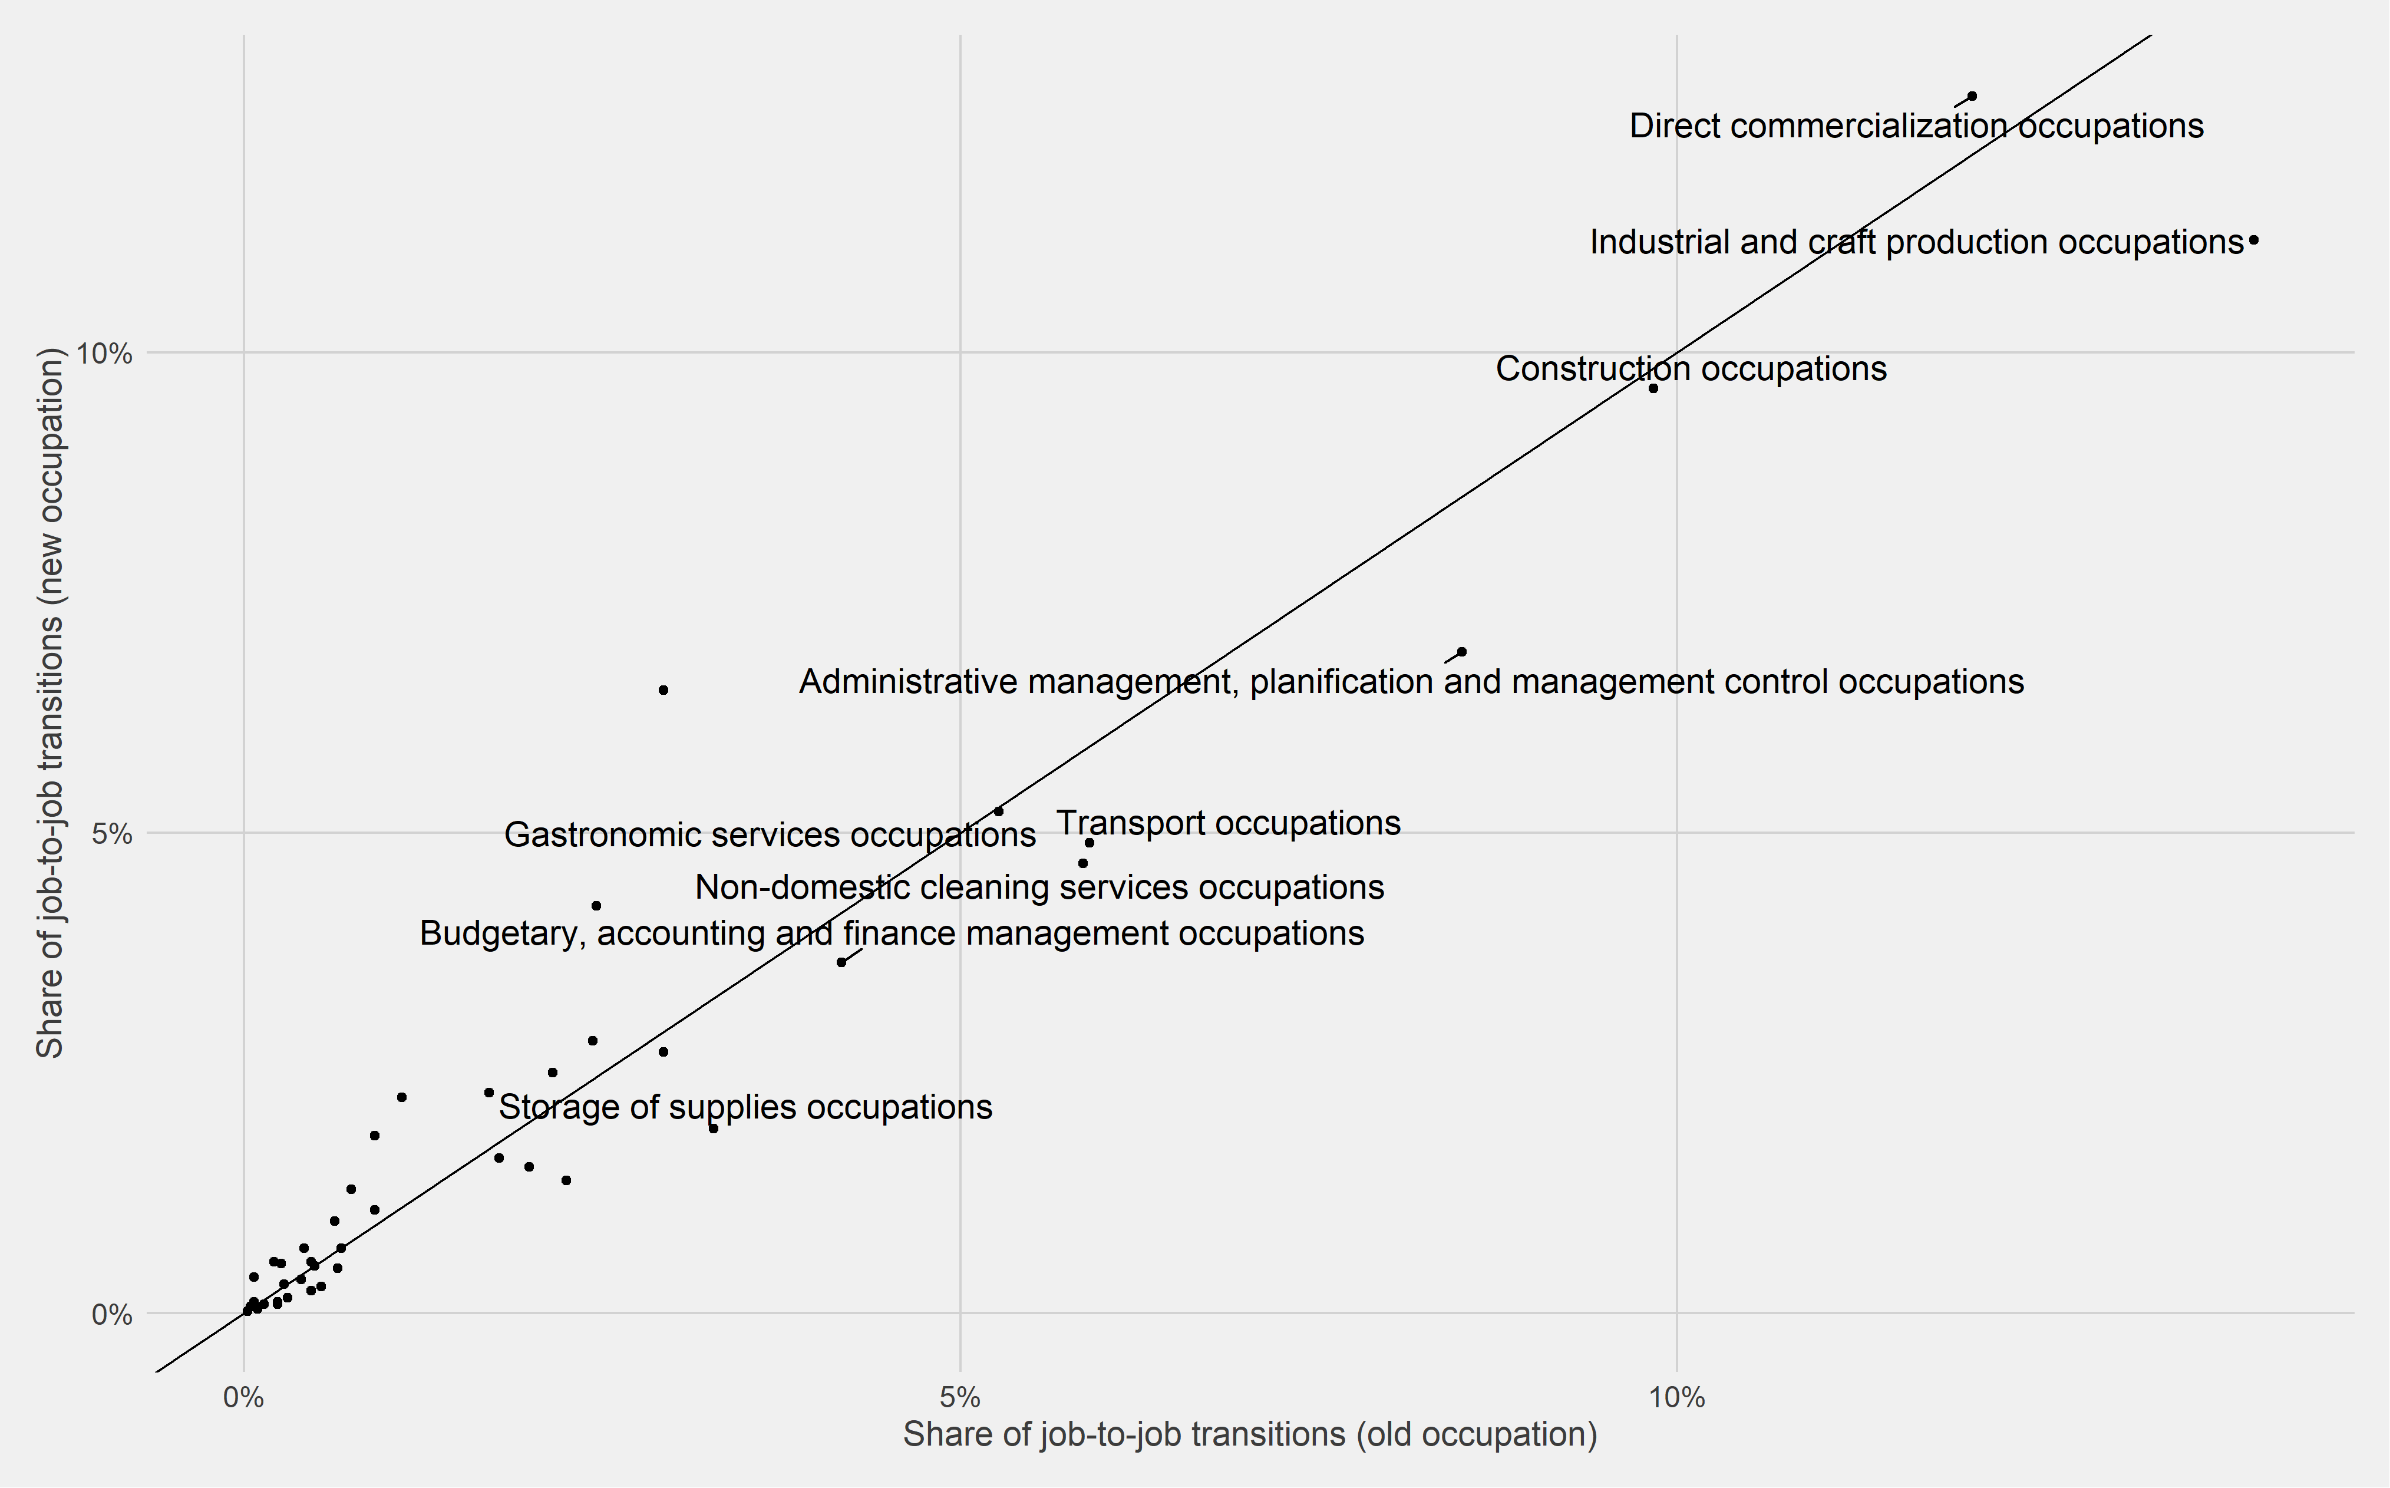

**Figure 2**. Distribution of occupations according to their participation in the total of transitions such as departure (old) and arrival (new) occupations. Elaborated by the authors based on the Permanent Household Survey (EPH).

Figure 3 shows the distribution of the distance measurement between each pair of occupations for the complete sample. In that plot we remove all pairs reporting a similarity index of -1, because a high number of pairs can be observed at the lowest part of the distribution, showing almost no connection between them. This may be due to the fact that, as a sample, some minority sectors are not well captured by the EPH-based analysis.

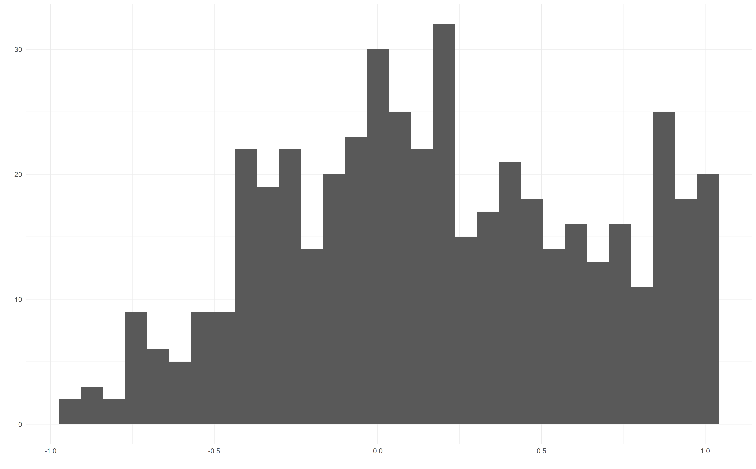

**Figure 3**. Distance distribution between pairs of occupations. Elaboration by the authors based on data from the Permanent Household Survey (EPH). Values of -1 are excluded from the plot.

After this small digression, Figure 4 shows the density map of similarity between the occupations analyzed with the formula based on Neffke et al (2017), centered on 0 and with limits between -1 and 1. As can be seen, the main diagonal shows the highest values in the measure of similarity derived simply from observing the flows between occupations and comparing them against a theoretical expected flow.

Even more interesting is the fact that the similarity measure appears to have high values in areas close to the main diagonal, while values represented by dark colors (low) are in the regions farther away from this diagonal, on average.

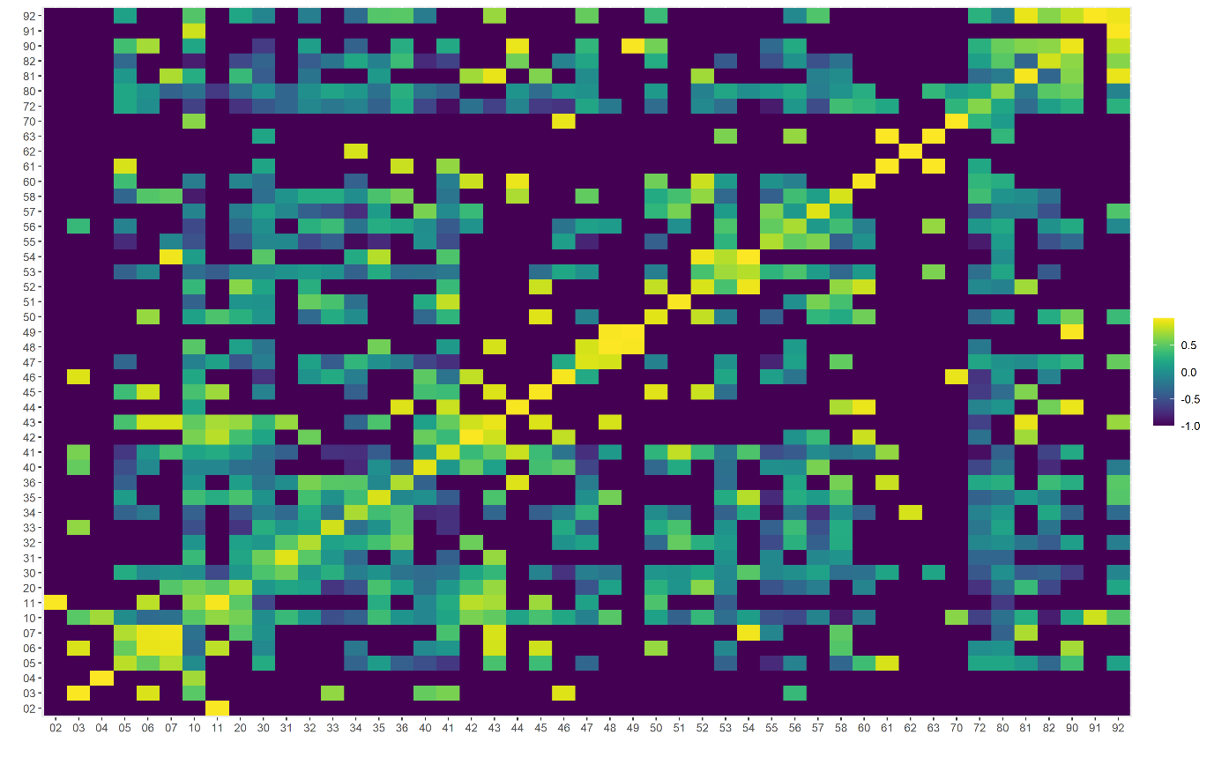

**Figure** 4. Density map among occupations of the National Occupation Code (CNO) based on data from the Permanent Household Survey (EPH)

This pattern gives us some clue that the most common occupational movements occur between occupational groups that generally have some similarity according to the CNO. This can be inferred by the high values shown along the main diagonal, which shows the similarity between the same CNO code and neighboring codes. This heatmap also shows how there are many occupations that are disconnected based on job-to-job transitions (similarity value of -1), but a few heavily connected occupational codes

This pattern is similar to that observed by Montané and Sartorio (2019) and De Raco and Semeshenko (2019) for movements between sectors of activity, for the Permanent Household Survey (EPH) in the first case, as for the administrative data derived from the Argentine Integrated System of Pensions (SIPA) in the case of the second job. It is also a pattern similar to that found, in country exports, by Hidalgo et al (2007).

## The occupational space

We can express this measure of distance between occupations through a weighted graph, as shown in Figure 5. In that figure we show all occupational codes, with the exception of managers and high-ranking officials in the government, and their ties with the rest of the occupational codes. The links width depicts how high is the relationship between two nodes, while the node size represents a strength each node has. The strength is the weighted graph’s adaptation of node degree. It shows the sum of all the links to other occupations, taking into account the intensity of the attraction.

We can see that that some occupations are closely linked to many occupations. This is the case of Consulting, Recreative services, administrative management, planification and management control and education, among others. Two occupations that explain 14% of the total employment in 2019 (Construction and domestic services) show low connectivity to other nodes.

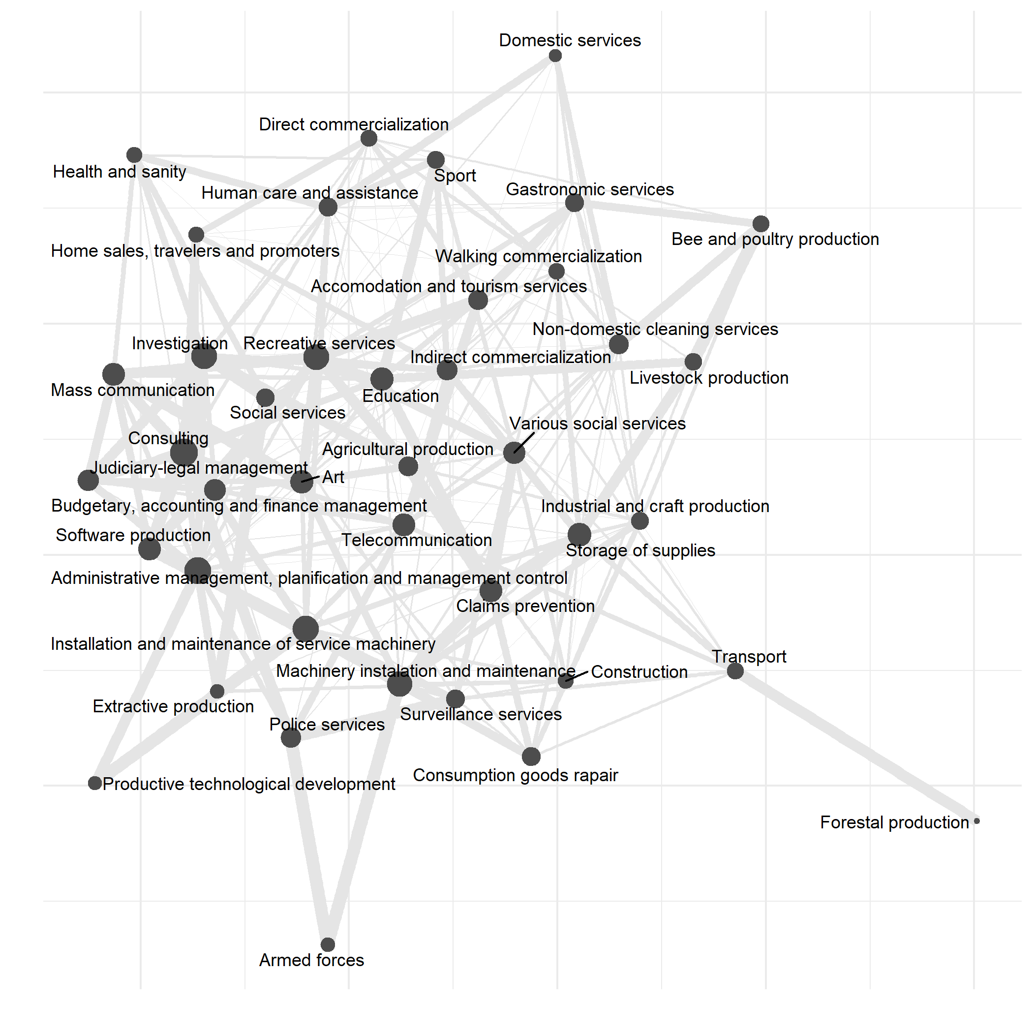

**Figure 5**. Weighted graph of occupation codes the transitions of the Permanent Household Survey (EPH). Negative values of similarity are excluded.

Although self-loops are excluded from the graph, something interesting about the movement of workers is the fact that transitions between same occupations are the rule rather than the exception. As an example, 7 of the 10 edges with the highest similarity value are jumps between the same occupation, and more than 43.5% of all job changes occur between the same occupations.

This pattern is not strange. The economic literature has studied the specificity of human capital at the level of occupations and tasks, finding important economic returns associated with practicing the same occupations or tasks for years. Even Nedelkoska et al (2018) has found that the variable in similarity between tasks, similar to the one we built for occupations, can help predict wage change.

What can we say about central occupations in the constructed graph? The distribution of strength can give us information about which occupations are more directly related to other occupations (Figure 6). We can see that the first 5 occupations with greater *strength* are those linked to Consulting, administrative management, planification and management control. Interestingly, domestic services, construction, transport and industrial and craft productions have low “attraction” to other occupational codes.

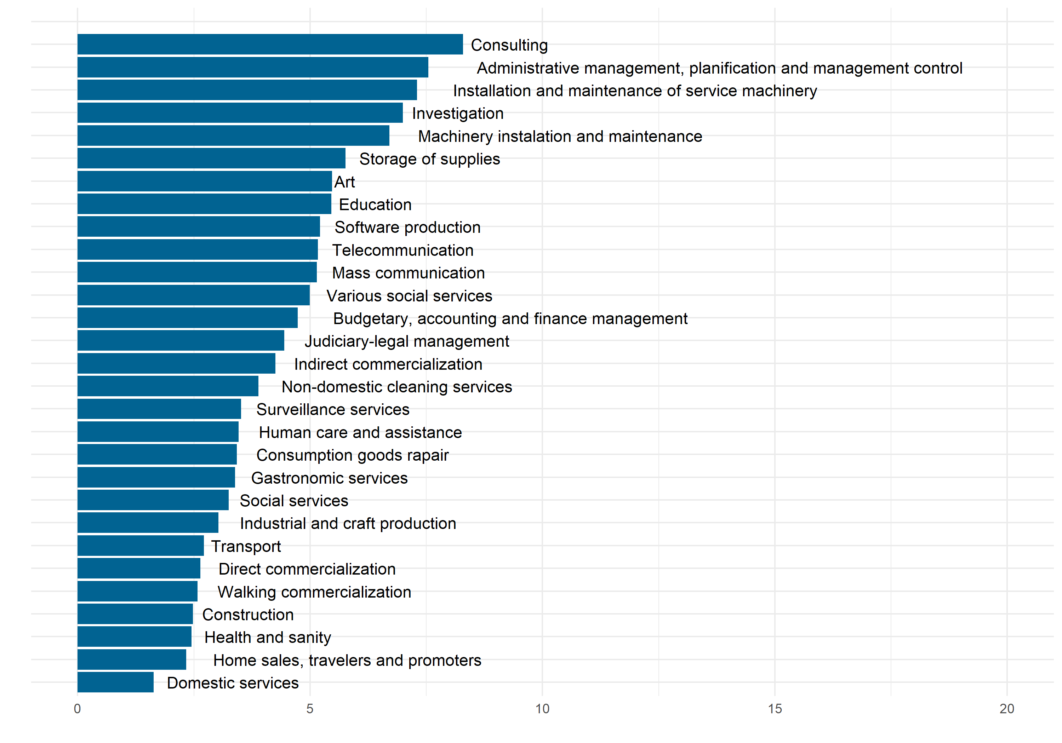**Figure 6.** Strengthof each of the vertices (occupations) of the weighted and addressed graph of occupations based on the transitions detected in the Permanent Household Survey (EPH)

## The specificity of human capital

Several studies have investigated in depth how general our human capital is (Poleteav and Robinson, 2008; Kambourov and Manovskii, 2009; Gathmann & Schonberg, 2010; Sulivan, 2010; Yamaguchi, 2012; Nedelkoska et al; 2018). By human capital we mean a set of intangible knowledge and experience that makes it possible for us to perform tasks and occupations in a successful way.

Knowing how specific our human capital is becoming especially relevant in the point of view of the costs of labor reconversion. If human capital wasn’t specific, a worker wouldn’t find greater problems in finding a new career path in the event that their occupation or tasks began to be deprecated - either by trade openness or technological change.

But if moving between occupations or tasks other than the initial ones comes at a significant cost in terms of worker productivity, then the costs of reconversion are high and the need for active reconversion and a set of policies that allow for a smooth transition between occupations become urgent.

Ideally, answering this question would require having some measure of worker productivity before and after moving between occupations in which they have experience and among others where they do not. Unfortunately, these productivity statistics are not usually captured in household surveys or administrative data, and even the purely observational nature of these measures would also not improve the situation.

In this way, various research resorted to an imperfect measure of labor productivity: the wages received by workers. Kambourov and Manovskii (2009) find that, after time-monitoring with the employer, the activity sector and many other controls, time spent in performing the same occupation explains an important part of the wage received. Gathmann and Schonberg (2010) go further, and with administrative data from Germany, in which they have a disaggregation of tasks at the individual level, they manage to identify a specific effect associated with the time that a worker has been performing the same task. Closer to our times, Nedelkoska et al (2018) find out that the similarity between the occupations through which workers move, in terms of the type of task and intensity with which it is applied, is a good predictor of wage changes.

The Permanent Household Survey allows us to perform an exercise similar to the rest of the investigations, but this time with evidence for Argentina. The first way to relate the similarity of occupations to changes in wages is to add the variable of similarity between occupations as the independent variable to explain the changes in wages.

One of the challenges in building a regression model only from the information of the *leaps* between jobs is that economic theory can helps us more in determining the level of wages than its variation in the short term. In fact, the Mincer equation, one of the most widely disseminated models, only includes variables that in the short term can be considered constant (educational level and years of work experience).

Due to this lack of theoretical models for such short-term movements, this work proposes to estimate several econometric models that control different variables that can affect the difference in wages observed before and after the change in employment. The most basic model could be defined as follows:



$∆RealWage=c+ R_{ij}$

Where $∆RealWage$ refers to the average quarterly change of the worker's real wage between the initial and the final[3] employment, $R_{ij}$ is the similarity variable created between the exit and destination occupation and c is a constant that represents the average of the wage variations.

Although 8,249 job-to-job transitions were available, only 5,640 cases contain simultaneously data on wages and data on hours worked (different from zero). The expected sign of the coefficient associated with the variable of similarity between occupations is positive, since greater similarity between the new occupation and the previous one should be associated with a higher salary and vice versa.

Table 1 shows the main results in the nine regressions that are shown in the Annex 2. If we estimate the regression the regression with the distance between occupations based in the total flows from job-to-job transitions, we find a mild and statistically non-significant relationship to changes in hourly real wage of 0.02. But the pooled sample consists of two methods of detection of job-to-job transitions: employer tenure and the report of an unemployment or inactivity spell between the transitions.

If we construct the similarity between occupations in the sample that are detected without transitioning through unemployment, we find a coefficient of 0.03 that is statistically significant. This means that an increase of one point in the similarity measure between occupations is, on average, linked to an increase of 3% the quarterly change of the real hourly wage in the job-to-job transition. This relationship doubles when the regression is run only in the subset of workers that have transitioned without going through an unemployment spell.

|  |  |  |  |
| --- | --- | --- | --- |
| **Distance based on** | **Subset in the regression** | | |
| Full Sample | Transition without unemployment | Transition with unemployment |
| Full Sample | 0.02 | 0.05 | -0.01 |
| Transition without unemployment | 0.03* | 0.06* | -0.01 |
| Transition with unemployment | 0.02 | 0.04 | 0.004 |

**Table 1**. Estimated coefficients of the similarity between occupations. Each regression has a dependent variable the quarterly change in hourly real wage at the beginning and the end of a job transition. Independent variables include the similarity between occupations, industries, two dummies that captures whether the worker was employed in a high paying industry before and after the transition, and two categorical variables that capture the employment relationship after and before the transition (independent worker, formal wage worker and informal wage worker) and time (year) dummies. * p value less than 10%.

That the link between occupation similarity and wage change is neater when working with the sample of workers that did not go through employment might the sign that workers that transitioned through a stage of unemployment are prone to switch occupations without benefiting from the specificity of their human capital, but are instead trying to find any job that is offered to them and can be secured. In this sense, the subsample of job-to-job transitions that did not go through unemployment is more likely to capture the occupational specificity of human capital and it relationship with wage changes.

However, the models seem to explain a very small part of the total variability of the data. For example, the value of R2 is always in the range of 1% and 3%. It is difficult to understand whether this value is high or low because the literature has not deeply researched short-term changes in work transitions.

## Conclusion

The ability of workers to reconvert their workforces at the lowest possible cost has been forced into the heart of the discussion as a consequence of technological change and trade openness. A key question to know the cost of conversion is how general or "portable" our human capital is.

Various research has pointed to this question, virtually exclusively in developing countries and using household survey data. Although there is no evidence in developing countries, Montané and Sartorio (2019) and De Raco and Semeshenko (2019) independently studied the similarity between sectors of activity and occupations, showing that there are certain changes between the sector of activity and occupation that are often more common than others, indicating a certain preference revealed by workers or geographical dependence on the labor market.

This work used public data prepared by the Institute of Statistics and Census of Argentina (INDEC). This data was used to investigate the pattern of occupational movement of workers and link those changes with the variations in time-wage when they change jobs. The data source was the Permanent Household Survey (EPH), which counts with a rotative panel that allows to observe short-term trajectories in the urban population of Argentina, up to approximately 18 months.

First, it was found that workers often switch between occupations that are mainly close in the National Catalogue of Occupations (CNO) listing, while no transitions are detected between many occupations. The resulting distance matrix is a sparse matrix, with many values close to -1, the lower bound of the similarity measure, and a smaller number of occupation pairs showing an intense attraction.

Second, several versions of a model that attempts to explain the variation in wages between previous and subsequent work were estimated. Several subsamples were tested, and, in most cases, a positive coefficient associated with distance measurement and hourly pay was obtained. In the preferred specification, where the distance is created based on workers that did not transitioned through employment, the coefficient is even larger and statistically significant.

Finally, this study has obvious limitations that need to be taken into account. First, these are short-term transitions. It would be very useful to have information in panel data with a long-term vision in order to allocate the experience in each of the occupations of each of the workers. Second, this is observational evidence, so one must be careful with its causal interpretation.

## Annex 1

|  |  |
| --- | --- |
| **Code** | **Description** |
| 0 | Executive officials |
| 1 | Legislative officials |
| 2 | Judiciary officials |
| 3 | Agencies, firms and state managers |
| 4 | Social institution managers |
| 5 | Small firm managers |
| 6 | Medium firm managers |
| 7 | Big firm managers |
| 10 | Administrative management, planification and management control occupations |
| 11 | Judiciary-legal management occupations |
| 20 | Budgetary, accounting and finance management occupations |
| 30 | Direct commercialization occupations |
| 31 | Home sales, travelers and promoters occupations |
| 32 | Indirect commercialization occupations |
| 33 | Walking commercialization occupations |
| 34 | Transport occupations |
| 35 | Telecommunication occupations |
| 36 | Storage of supplies occupations |
| 40 | Health and sanity occupations |
| 41 | Education occupations |
| 42 | Investigation occupations |
| 43 | Consulting occupations |
| 44 | Claims prevention occupations |
| 45 | Mass communication occupations |
| 46 | Social services occupations |
| 47 | Surveillance services occupations |
| 48 | Police services occupations |
| 49 | Armed forces occupations |
| 50 | Art occupations |
| 51 | Sport occupations |
| 52 | Recreative services occupations |
| 53 | Gastronomic services occupations |
| 54 | Accomodation and tourism services occupations |
| 55 | Domestic services occupations |
| 56 | Non-domestic cleaning services occupations |
| 57 | Human care and assistance occupations |
| 58 | Various social services occupations |
| 60 | Agricultural production occupations |
| 61 | Livestock production occupations |
| 62 | Forestal production occupations |
| 63 | Bee and poultry production occupations |
| 64 | Fishing production occupations |
| 65 | Hunting occupations |
| 70 | Extractive production occupations |
| 71 | Energy, gas and water production occupations |
| 72 | Construction occupations |
| 80 | Industrial and craft production occupations |
| 81 | Software production occupations |
| 82 | Consumption goods rapair occupations |
| 90 | Machinery instalation and maintenance occupations |
| 91 | Productive technological development occupations |
| 92 | Installation and maintenance of service machinery occupations |

Table A1. Occupations of the National Occupational Code (CNO) 2001.

## Annex 2

|  |  |  |  |  |  |  |
| --- | --- | --- | --- | --- | --- | --- |
| Dep var  QuarterlyChangeRealHourlyWage | estimate | std.error | p.value | Lb (CI 90%) | Ub (CI 90%) | coefPvalue |
| (Intercept) | 0.48 | 0.14 | 0.00 | 0.26 | 0.70 | 0.48*** |
| RijOccupation | 0.02 | 0.03 | 0.50 | -0.03 | 0.08 | 0.02 |
| RijIndustry | -0.03 | 0.03 | 0.31 | -0.08 | 0.02 | -0.03 |
| IndustryAboveAvg_Lagged | -0.06 | 0.03 | 0.05 | -0.11 | -0.01 | -0.06** |
| IndustryAboveAvg | 0.04 | 0.03 | 0.18 | -0.01 | 0.09 | 0.04 |
| **LaborContractLagged (base case: informal wage worker)** |  |  |  |  |  |  |
| Formal wage worker | -0.10 | 0.03 | 0.00 | -0.15 | -0.05 | -0.1*** |
| Independent worker | 0.07 | 0.03 | 0.03 | 0.02 | 0.12 | 0.07** |
| **LaborContract (base case: informal wage worker)** |  |  |  |  |  |  |
| Formal wage worker | 0.06 | 0.03 | 0.03 | 0.02 | 0.11 | 0.06** |
| Independent worker | -0.11 | 0.04 | 0.00 | -0.17 | -0.05 | -0.11*** |
| R2 | 0.011 |  |  |  |  |  |
| n | 4918 |  |  |  |  |  |

**Table A2.1**. Regression output. Dependent variable: average quarterly change in real hourly wage before and after a job transition. Independent variables include the similarity between occupations (RijOccupation), industries (RijIndustriy), two dummies that captures whether the worker was employed in a high paying industry before (IndustryAboveAvg_Lagged) and after (IndustryAboveAvg) the transition, and two categorical variables that capture the employment relationship after (LaborContract) and before (LaborContractLagged) the transition (independent worker, formal waged worker and informal waged worker) and time (year) dummies. * p value less than 10%. ** p value less than 5%, *** p value less than 1%. Industry and occupation similarity have been build based on all transitions. The sample in this regression is the full sample.

|  |  |  |  |  |  |  |
| --- | --- | --- | --- | --- | --- | --- |
| Dep var  QuarterlyChangeRealHourlyWage | estimate | std.error | p.value | Lb (CI 90%) | Ub (CI 90%) | coefPvalue |
| (Intercept) | 0.47 | 0.13 | 0.00 | 0.25 | 0.69 | 0.47*** |
| RijOccupation | 0.03 | 0.02 | 0.07 | 0.00 | 0.06 | 0.03* |
| RijIndustry | -0.01 | 0.02 | 0.44 | -0.04 | 0.02 | -0.01 |
| IndustryAboveAvg_Lagged | -0.06 | 0.03 | 0.07 | -0.11 | -0.01 | -0.06* |
| IndustryAboveAvg | 0.04 | 0.03 | 0.24 | -0.01 | 0.09 | 0.04 |
| **LaborContractLagged (base case: informal wage worker)** |  |  |  |  |  |  |
| Formal wage worker | -0.10 | 0.03 | 0.00 | -0.15 | -0.05 | -0.1*** |
| Independent worker | 0.06 | 0.03 | 0.05 | 0.01 | 0.11 | 0.06* |
| **LaborContract (base case: informal wage worker)** |  |  |  |  |  |  |
| Formal wage worker | 0.07 | 0.03 | 0.02 | 0.02 | 0.12 | 0.07** |
| Independent worker | -0.10 | 0.04 | 0.01 | -0.16 | -0.04 | -0.1*** |
| R2 | 0.01 | #N/A | #N/A | #N/A | #N/A | #N/A |
| n | 4770 | #N/A | #N/A | #N/A | #N/A | #N/A |

**Table A2.2**. Regression output. Dependent variable: average quarterly change in real hourly wage before and after a job transition. Independent variables include the similarity between occupations (RijOccupation), industries (RijIndustriy), two dummies that captures whether the worker was employed in a high paying industry before (IndustryAboveAvg_Lagged) and after (IndustryAboveAvg) the transition, and two categorical variables that capture the employment relationship after (LaborContract) and before (LaborContractLagged) the transition (independent worker, formal waged worker and informal waged worker) and time (year) dummies. * p value less than 10%. ** p value less than 5%, *** p value less than 1%. Industry and occupation similarity have been build based on all job transitions that did not go through a period of unemployment. The sample in this regression is the full sample.

|  |  |  |  |  |  |  |
| --- | --- | --- | --- | --- | --- | --- |
| Dep var  QuarterlyChangeRealHourlyWage | estimate | std.error | p.value | Lb (CI 90%) | Ub (CI 90%) | coefPvalue |
| (Intercept) | 0.48 | 0.14 | 3.54 | 0.00 | 0.26 | 0.70 |
| RijOccupation | 0.02 | 0.03 | 0.85 | 0.40 | -0.02 | 0.07 |
| RijIndustry | -0.02 | 0.02 | -0.88 | 0.38 | -0.06 | 0.02 |
| IndustryAboveAvg_Lagged | -0.07 | 0.03 | -2.25 | 0.02 | -0.12 | -0.02 |
| IndustryAboveAvg | 0.05 | 0.03 | 1.58 | 0.11 | 0.00 | 0.10 |
| **LaborContractLagged (base case: informal wage worker)** |  |  |  |  |  |  |
| Formal wage worker | -0.10 | 0.03 | -3.40 | 0.00 | -0.15 | -0.05 |
| Independent worker | 0.07 | 0.03 | 2.20 | 0.03 | 0.02 | 0.12 |
| **LaborContract (base case: informal wage worker)** |  |  |  |  |  |  |
| Formal wage worker | 0.06 | 0.03 | 1.99 | 0.05 | 0.01 | 0.11 |
| Independent worker | -0.11 | 0.04 | -3.04 | 0.00 | -0.17 | -0.05 |
| R2 | 0.01 | #N/A | #N/A | #N/A | #N/A | #N/A |
| n | 4896.00 | #N/A | #N/A | #N/A | #N/A | #N/A |

**Table A2.3**. Regression output. Dependent variable: average quarterly change in real hourly wage before and after a job transition. Independent variables include the similarity between occupations (RijOccupation), industries (RijIndustriy), two dummies that captures whether the worker was employed in a high paying industry before (IndustryAboveAvg_Lagged) and after (IndustryAboveAvg) the transition, and two categorical variables that capture the employment relationship after (LaborContract) and before (LaborContractLagged) the transition (independent worker, formal waged worker and informal waged worker) and time (year) dummies. * p value less than 10%. ** p value less than 5%, *** p value less than 1%. Industry and occupation similarity have been build based on all job transitions that went through a period of unemployment. The sample in this regression is the full sample.

|  |  |  |  |  |  |  |
| --- | --- | --- | --- | --- | --- | --- |
| Dep var  QuarterlyChangeRealHourlyWage | estimate | std.error | p.value | Lb (CI 90%) | Ub (CI 90%) | coefPvalue |
| (Intercept) | 0.48 | 0.18 | 2.66 | 0.01 | 0.19 | 0.78 |
| RijOccupation | 0.05 | 0.06 | 0.81 | 0.42 | -0.05 | 0.15 |
| RijIndustry | -0.03 | 0.06 | -0.61 | 0.54 | -0.13 | 0.06 |
| IndustryAboveAvg_Lagged | -0.08 | 0.05 | -1.48 | 0.14 | -0.17 | 0.01 |
| IndustryAboveAvg | 0.05 | 0.05 | 0.86 | 0.39 | -0.04 | 0.13 |
| **LaborContractLagged (base case: informal wage worker)** |  |  |  |  |  |  |
| Formal wage worker | -0.14 | 0.05 | -2.70 | 0.01 | -0.22 | -0.05 |
| Independent worker | 0.05 | 0.06 | 0.95 | 0.34 | -0.04 | 0.14 |
| **LaborContract (base case: informal wage worker)** |  |  |  |  |  |  |
| Formal wage worker | 0.07 | 0.05 | 1.38 | 0.17 | -0.01 | 0.15 |
| R2 | 0.01 | #N/A | #N/A | #N/A | #N/A | #N/A |
| n | 2646 | #N/A | #N/A | #N/A | #N/A | #N/A |

**Table A2.4**. Regression output. Dependent variable: average quarterly change in real hourly wage before and after a job transition. Independent variables include the similarity between occupations (RijOccupation), industries (RijIndustriy), two dummies that captures whether the worker was employed in a high paying industry before (IndustryAboveAvg_Lagged) and after (IndustryAboveAvg) the transition, and two categorical variables that capture the employment relationship after (LaborContract) and before (LaborContractLagged) the transition (independent worker, formal waged worker and informal waged worker) and time (year) dummies. * p value less than 10%. ** p value less than 5%, *** p value less than 1%. Industry and occupation similarity have been build based on all job-to-job transitions. The sample in this regression comprises all the job-to-job transitions that do not include a period of unemployment.

|  |  |  |  |  |  |  |
| --- | --- | --- | --- | --- | --- | --- |
| Dep var  QuarterlyChangeRealHourlyWage | estimate | std.error | p.value | Lb (CI 90%) | Ub (CI 90%) | coefPvalue |
| (Intercept) | 0.47 | 0.18 | 2.64 | 0.01 | 0.18 | 0.77 |
| RijOccupation | 0.06 | 0.04 | 1.70 | 0.09 | 0.00 | 0.12 |
| RijIndustry | -0.05 | 0.03 | -1.43 | 0.15 | -0.10 | 0.01 |
| IndustryAboveAvg_Lagged | -0.07 | 0.05 | -1.38 | 0.17 | -0.16 | 0.01 |
| IndustryAboveAvg | 0.04 | 0.05 | 0.76 | 0.45 | -0.05 | 0.13 |
| **LaborContractLagged (base case: informal wage worker)** |  |  |  |  |  |  |
| Formal wage worker | -0.14 | 0.05 | -2.70 | 0.01 | -0.23 | -0.05 |
| Independent worker | 0.05 | 0.06 | 0.87 | 0.39 | -0.04 | 0.14 |
| **LaborContract (base case: informal wage worker)** |  |  |  |  |  |  |
| Formal wage worker | 0.08 | 0.05 | 1.64 | 0.10 | 0.00 | 0.16 |
| R2 | 0.01 | #N/A | #N/A | #N/A | #N/A | #N/A |
| n | 2588 | #N/A | #N/A | #N/A | #N/A | #N/A |

**Table A2.5**. Regression output. Dependent variable: average quarterly change in real hourly wage before and after a job transition. Independent variables include the similarity between occupations (RijOccupation), industries (RijIndustriy), two dummies that captures whether the worker was employed in a high paying industry before (IndustryAboveAvg_Lagged) and after (IndustryAboveAvg) the transition, and two categorical variables that capture the employment relationship after (LaborContract) and before (LaborContractLagged) the transition (independent worker, formal waged worker and informal waged worker) and time (year) dummies. * p value less than 10%. ** p value less than 5%, *** p value less than 1%. Industry and occupation similarity have been build based on all job transitions that did not go through a period of unemployment. The sample in this regression comprises all the job-to-job transitions that do not include a period of unemployment.

|  |  |  |  |  |  |  |
| --- | --- | --- | --- | --- | --- | --- |
| Dep var  QuarterlyChangeRealHourlyWage | estimate | std.error | p.value | Lb (CI 90%) | Ub (CI 90%) | coefPvalue |
| (Intercept) | 0.48 | 0.18 | 2.64 | 0.01 | 0.18 | 0.78 |
| RijOccupation | 0.04 | 0.05 | 0.87 | 0.38 | -0.04 | 0.12 |
| RijIndustry | 0.00 | 0.04 | 0.04 | 0.97 | -0.06 | 0.06 |
| IndustryAboveAvg_Lagged | -0.09 | 0.05 | -1.65 | 0.10 | -0.18 | 0.00 |
| IndustryAboveAvg | 0.06 | 0.05 | 1.16 | 0.24 | -0.03 | 0.15 |
| **LaborContractLagged (base case: informal wage worker)** |  |  |  |  |  |  |
| Formal wage worker | -0.15 | 0.05 | -2.87 | 0.00 | -0.23 | -0.06 |
| Independent worker | 0.06 | 0.06 | 1.05 | 0.29 | -0.03 | 0.15 |
| **LaborContract (base case: informal wage worker)** |  |  |  |  |  |  |
| Formal wage worker | 0.06 | 0.05 | 1.26 | 0.21 | -0.02 | 0.14 |
| R2 | 0.01 |  |  |  |  |  |
| n | 2625 |  |  |  |  |  |

**Table A2.6**. Regression output. Dependent variable: average quarterly change in real hourly wage before and after a job transition. Independent variables include the similarity between occupations (RijOccupation), industries (RijIndustriy), two dummies that captures whether the worker was employed in a high paying industry before (IndustryAboveAvg_Lagged) and after (IndustryAboveAvg) the transition, and two categorical variables that capture the employment relationship after (LaborContract) and before (LaborContractLagged) the transition (independent worker, formal waged worker and informal waged worker) and time (year) dummies. * p value less than 10%. ** p value less than 5%, *** p value less than 1%. Industry and occupation similarity have been build based on all job transitions that went through a period of unemployment. The sample in this regression comprises all the job-to-job transitions that do not include a period of unemployment.

|  |  |  |  |  |  |  |
| --- | --- | --- | --- | --- | --- | --- |
| Dep var  QuarterlyChangeRealHourlyWage | estimate | std.error | p.value | Lb (CI 90%) | Ub (CI 90%) | coefPvalue |
| (Intercept) | 0.08 | 0.03 | 2.28 | 0.02 | 0.02 | 0.13 |
| RijOccupation | -0.01 | 0.02 | -0.48 | 0.63 | -0.03 | 0.02 |
| RijIndustry | 0.01 | 0.01 | 0.45 | 0.65 | -0.02 | 0.03 |
| IndustryAboveAvg_Lagged | -0.03 | 0.01 | -1.97 | 0.05 | -0.05 | 0.00 |
| IndustryAboveAvg | 0.03 | 0.01 | 1.81 | 0.07 | 0.00 | 0.05 |
| **LaborContractLagged (base case: informal wage worker)** |  |  |  |  |  |  |
| Formal wage worker | -0.05 | 0.02 | -3.12 | 0.00 | -0.07 | -0.02 |
| Independent worker | 0.05 | 0.01 | 3.58 | 0.00 | 0.03 | 0.07 |
| **LaborContract (base case: informal wage worker)** |  |  |  |  |  |  |
| Formal wage worker | 0.02 | 0.02 | 1.38 | 0.17 | 0.00 | 0.05 |
| Independent worker | -0.01 | 0.01 | -0.65 | 0.52 | -0.03 | 0.01 |
| R2 | 0.03 |  |  |  |  |  |
| n | 2272 |  |  |  |  |  |

**Table A2.7**. Regression output. Dependent variable: average quarterly change in real hourly wage before and after a job transition. Independent variables include the similarity between occupations (RijOccupation), industries (RijIndustriy), two dummies that captures whether the worker was employed in a high paying industry before (IndustryAboveAvg_Lagged) and after (IndustryAboveAvg) the transition, and two categorical variables that capture the employment relationship after (LaborContract) and before (LaborContractLagged) the transition (independent worker, formal waged worker and informal waged worker) and time (year) dummies. * p value less than 10%. ** p value less than 5%, *** p value less than 1%. Industry and occupation similarity have been build based on all job transitions. The sample in this regression comprises all the job-to-job transitions that include a period of unemployment.

|  |  |  |  |  |  |  |
| --- | --- | --- | --- | --- | --- | --- |
| Dep var  QuarterlyChangeRealHourlyWage | estimate | std.error | p.value | Lb (CI 90%) | Ub (CI 90%) | coefPvalue |
| (Intercept) | 0.03 | 0.03 | 0.98 | 0.33 | -0.02 | 0.09 |
| RijOccupation | -0.01 | 0.01 | -1.27 | 0.20 | -0.02 | 0.00 |
| RijIndustry | 0.01 | 0.01 | 0.74 | 0.46 | -0.01 | 0.02 |
| IndustryAboveAvg_Lagged | -0.02 | 0.02 | -1.66 | 0.10 | -0.05 | 0.00 |
| IndustryAboveAvg | 0.02 | 0.02 | 1.55 | 0.12 | 0.00 | 0.05 |
| **LaborContractLagged (base case: informal wage worker)** |  |  |  |  |  |  |
| Formal wage worker | -0.05 | 0.02 | -3.08 | 0.00 | -0.07 | -0.02 |
| Independent worker | 0.05 | 0.01 | 3.24 | 0.00 | 0.02 | 0.07 |
| **LaborContract (base case: informal wage worker)** |  |  |  |  |  |  |
| Formal wage worker | 0.02 | 0.02 | 1.39 | 0.16 | 0.00 | 0.05 |
| Independent worker | -0.01 | 0.01 | -0.54 | 0.59 | -0.03 | 0.02 |
| R2 | 0.03 |  |  |  |  |  |
| n | 2182 |  |  |  |  |  |

**Table A2.8**. Regression output. Dependent variable: average quarterly change in real hourly wage before and after a job transition. Independent variables include the similarity between occupations (RijOccupation), industries (RijIndustriy), two dummies that captures whether the worker was employed in a high paying industry before (IndustryAboveAvg_Lagged) and after (IndustryAboveAvg) the transition, and two categorical variables that capture the employment relationship after (LaborContract) and before (LaborContractLagged) the transition (independent worker, formal waged worker and informal waged worker) and time (year) dummies. * p value less than 10%. ** p value less than 5%, *** p value less than 1%. Industry and occupation similarity have been built based on all job transitions that did not go through a period of unemployment. The sample in this regression comprises all the job-to-job transitions that include a period of unemployment.

|  |  |  |  |  |  |  |
| --- | --- | --- | --- | --- | --- | --- |
| Dep var  QuarterlyChangeRealHourlyWage | estimate | std.error | p.value | Lb (CI 90%) | Ub (CI 90%) | coefPvalue |
| (Intercept) | 0.07 | 0.03 | 2.23 | 0.03 | 0.02 | 0.13 |
| RijOccupation | 0.00 | 0.02 | 0.24 | 0.81 | -0.02 | 0.03 |
| RijIndustry | 0.00 | 0.01 | -0.09 | 0.93 | -0.02 | 0.02 |
| IndustryAboveAvg_Lagged | -0.03 | 0.01 | -1.97 | 0.05 | -0.05 | 0.00 |
| IndustryAboveAvg | 0.03 | 0.01 | 1.83 | 0.07 | 0.00 | 0.05 |
| **LaborContractLagged (base case: informal wage worker)** |  |  |  |  |  |  |
| Formal wage worker | -0.05 | 0.02 | -3.12 | 0.00 | -0.07 | -0.02 |
| Independent worker | 0.05 | 0.01 | 3.58 | 0.00 | 0.03 | 0.07 |
| **LaborContract (base case: informal wage worker)** |  |  |  |  |  |  |
| Formal wage worker | 0.02 | 0.02 | 1.39 | 0.17 | 0.00 | 0.05 |
| Independent worker | -0.01 | 0.01 | -0.70 | 0.48 | -0.03 | 0.01 |
| R2 | 0.03 |  |  |  |  |  |
| n | 2271 |  |  |  |  |  |

**Table A2.9**. Regression output. Dependent variable: average quarterly change in real hourly wage before and after a job transition. Independent variables include the similarity between occupations (RijOccupation), industries (RijIndustriy), two dummies that captures whether the worker was employed in a high paying industry before (IndustryAboveAvg_Lagged) and after (IndustryAboveAvg) the transition, and two categorical variables that capture the employment relationship after (LaborContract) and before (LaborContractLagged) the transition (independent worker, formal waged worker and informal waged worker) and time (year) dummies. * p value less than 10%. ** p value less than 5%, *** p value less than 1%. Industry and occupation similarity have been built based on all job transitions that went through a period of unemployment. The sample in this regression comprises all the job-to-job transitions that include a period of unemployment.

## Bibliografía

Balassa, B. (1986). Intra-industry specialization: a cross-country analysis. *European Economic Review*, *30*(1), 27-42.

DE RACO, Sergio Andrés; SEMESHENKO, Viktoriya. Labor mobility and industrial space in Argentina. Journal of Dynamics & Games, 2019, vol. 6, no 2, p. 107-118.

Gathmann, C., & Schönberg, U. (2010). How general is human capital? A task-based approach. *Journal of Labor Economics*, *28*(1), 1-49.

Hidalgo, C. A., & Hausmann, R. (2009). The building blocks of economic complexity. *Proceedings of the national academy of sciences*, *106*(26), 10570-10575.

Hidalgo, C. A., Klinger, B., Barabási, A. L., & Hausmann, R. (2007). The product space conditions the development of nations. *Science*, *317*(5837), 482-487.

Kambourov, G., & Manovskii, I. (2009). Occupational specificity of human capital. *International Economic Review*, *50*(1), 63-115.

MONTANÉ, Martín; SARTORIO, Luca. Tecnología y generación de empleo en el siglo XXI: desafíos y propuestas. Premio de la Academia Nacional de Ciencias Morales y Políticas, 2019.

Nedelkoska, L., Diodato, D., & Neffke, F. (2018). *Is Our Human Capital General Enough to Withstand the Current Wave of Technological Change?* (No. 93a). Center for International Development at Harvard University.

Neffke, F., & Henning, M. (2013). Skill relatedness and firm diversification. *Strategic Management Journal*, *34*(3), 297-316.

Sullivan, P. (2010). Empirical evidence on occupation and industry specific human capital. *Labour economics*, *17*(3), 567-580.

Yamaguchi, S. (2012). Tasks and heterogeneous human capital. *Journal of Labor Economics*, *30*(1), 1-53.

1. We believe that replication of scientific studies is a necessary condition for the improvement of science. Codes and data are publicly available at <https://github.com/martinmontane/EPHOcupaciones>. Any error or suggestions in the code or data will be most welcome at martinmontane@gmail.com
2. This period coincided with a sample change in the EPH, which could partially explain this change.
3. The quarterly average is calculated instead of the variation between the two points because the regression pools movements of 1, 3 and 4 quarters. In an inflationary context, such as the one that Argentina is experiencing, longer transitions may be penalized.